Classification of SAR images into Ships and Icebergs Using CNN

Anshul Shrivastava 1, Ali Nasir Bandukwala 2

*1 # Centre of studies in resource engineering, Indian Institute of Technology (IIT) Bombay, 400076, Mumbai, Maharashtra*

1 [a.nasir0001@gmail.com](mailto:a.nasir0001@gmail.com), 2[ashu009@gamil.com](mailto:ashu009@gamil.com)

**KEY WORDS: Deep learning, Convolutional neural networks (CNNs), Classification**

**ABSTRACT:**

Convolutional neural networks (CNNs) which are a kind of advanced artificial neural networks (ANNs) have been widely used for the analysis of remotely sensed imagery. However, their application to multispectral and hyperspectral images faces some challenges, especially related to the processing of the high-dimensional information contained in multidimensional data cubes. This results in a significant increase in computation time. This paper is on **a deep convolutional neural network image classification,** which can be used for the detection of icebergs as well as ships using the SAR imagery. This model will help in identifying an object as a ship or iceberg from a very low resolution 2 band image.

# **INTRODUCTION**

Space-borne Synthetic Aperture Radar (SAR) is an important instrument for oceanographic observations. Due to its active radar, it is able to monitor the oceans and floating structures in all weather conditions. In SAR images, ships and icebergs typically have a stronger backscatter response than the surrounding open water, and are therefore detectable using adaptive threshold techniques.

Icebergs are pieces of ice that formed on land and float in an ocean or lake. Icebergs come in all shapes and sizes, from ice-cube-sized chunks to ice islands the size of a small country. The term "iceberg" refers to chunks of ice larger than 5 meters (16 feet) across. Smaller icebergs, known as [bergy bits](https://nsidc.org/cgi-bin/words/word.pl?bergy%20bit) and [growlers](https://nsidc.org/cgi-bin/words/word.pl?growler), can be especially dangerous for ships because they are harder to spot. The North Atlantic and the cold waters surrounding Antarctica are home to most of the icebergs on Earth. Icebergs occur in a large variety of sizes and shapes, imposing additional challenge to their detection in SAR images. After detection, additional processing is needed to distinguish between ships and icebergs. The discrimination between the two classes is carried out through feature extraction and target classification steps.Drifting icebergs present threats to navigation and activities in areas such as offshore of the East Coast of Canada.Currently, many institutions and companies use aerial reconnaissance and shore-based support to monitor environmental conditions and assess risks from icebergs. However, in remote areas with particularly harsh weather, these methods are not feasible, and the only viable monitoring option is via satellite.

This abstract proposes the application of Convolutional Neural Networks (CNN) to ship-iceberg discrimination in low resolution SAR data. Convolutional Neural Networks are able to learn complex representations from the input data, without the need of handcrafted features, and have been successfully used in many image classification tasks. Only recently CNN has been successfully adopted for demanding SAR classification tasks. This abstract is organized as follows: first it describes the dataset and CNN architecture used in our experiments. Then presents the experimental results using the proposed model trained with targets extracted. Finally, it presents our conclusions and future work.

.

.

# **DATA ANALYSIS**

The data is presented in the json format. The files consist of a list of images, and for each image, you can find the following fields:

**id -** the id of the image

**band_1, band_2 -** the [flattened](https://docs.scipy.org/doc/numpy-1.13.0/reference/generated/numpy.ndarray.flatten.html) image data. Each band has 75x75 pixel values in the list, so the list has 5625 elements. Note that these values are not the normal non-negative integers in image files since they have physical meanings - these are float numbers with unit being [dB](https://en.wikipedia.org/wiki/Decibel). Band 1 and Band 2 are signals characterized by radar backscatter produced from different polarizations at a particular incidence angle. The polarizations correspond to HH (transmit/receive horizontally) and HV (transmit horizontally and receive vertically).

**The inc_angle** is the incidence angle of which the image was taken.

In order to represent the images in standard 3 channels composition we have used the average of the first and second band as the third band.

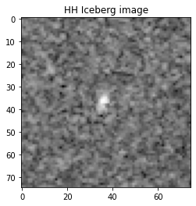

**Figure 1**

is_iceberg is the target variable, set to 1 if it is an iceberg, and 0 if it is a ship.Our dataset consists of 1604 images of icebergs and ships. Around 47 percent of the total images are of iceberg and 53 percent of the total images are of ships.

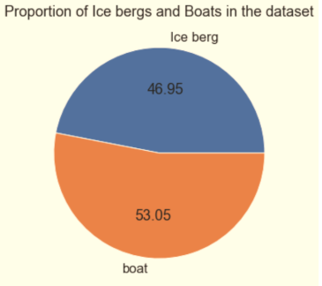

**Figure 2**

Pixel values are in dB and are negative float values. Therefore, it was essential to scale their values in the range of 0 to 1, both for the purpose of modeling as well as reading the images.

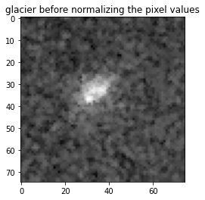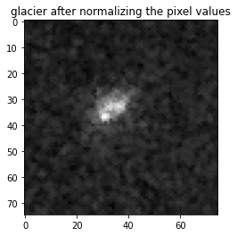

**Figure 3**

The expression that we have used to scale the values in the 0 to 1 range is *exponent( db/20).*The images in figure 3 shows the difference between the scalled and the raw images.In the field of image analysis and restoration, noise plays the most prominent role. Speckle noise is a granular pattern, a special kind of noise that is mainly found in satellite images, removing such noise is one of the major challenges and least touched issue. These satellite images are captured by a special kind of radar named as Synthetic Aperture Radar. Speckle noise is an undesirable effect. The source of this type of noise is caused due to random interference between the coherent returns issued from the so many scatterers present on an earth surface, on the scale of a wavelength of the incident radar wave. In general, speckle noise is the grainy salt-and-pepper pattern present in radar imagery. This paper analyses the effects of speckle noise into the SAR image using probability density function.

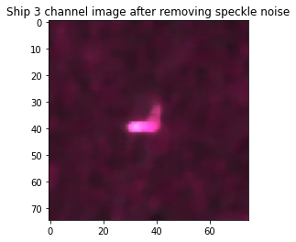 **Figure 4**

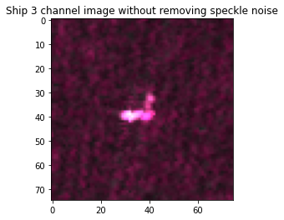

**Figure 5**

The images in figure 4 and figure 5 show the visible difference in the quality of images after removal of the speckle noise from the image. Image becomes more smooth after eliminating the speckle noise. We have used the median filtering to remove this noise from the images.

**3.**  **METHOD**

We have used Convolutional Neural Network to model our classification algorithm. CNNs are recognized to perform better than conventional deep neural networks in various computer vision tasks because they reduce the large number of the input features which are required in deep neural networks. The CNNs are good in extracting the features with each layer and using these extracted features to map the input image to the corresponding target label.

We have used Keras API with tensor flow libraries at the backend. Keras is widely used for deep learning and modeling because of its code readability and easy implementation.

Our model is of Sequential type. It consists of 4 convolutional layers and 2 deep layers with relu as the activation function.

Output layer consists of a sigmoid layer as we are classifying our images into two categories of glacier or ships. We compiled our model using the loss function as binary cross entropy with the help of Adam optimizer with learning rate of 0..001and epsilon of 1e-08. We split our dataset into 1000 train images and 604 test images. We trained our model for 10 epochs and 30 epochs with a batch size of 300. We have used the keras-tuner library to tune the hyper parameters like the number of dense layers, number of convolutional layers, optimizers etc. Randomized Search method of keras - tuner did a lot of the computational work automatically without letting us know. It came up with the best parameters out of several combinations of parameters.

# 4. **PERFORMANCE EVALUATION**

We trained our model on 10 epochs and 30 epochs. After completing training on 10 epochs it was evident that the model can be improved by increasing the number of epochs after visualising the graphs with tensorboard.Considering the unavailability of GPU, in order to avoid over training of the model or any kind of overfitting we came up with with 30 epochs while maintaining the same batch size of 100.



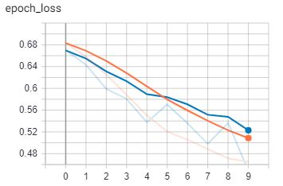

**Figure 6**

As we can see in figure 6, the loss is continuously decreasing both for the training data and for the test data. Therefore, we decided to train the model on 30 epochs.



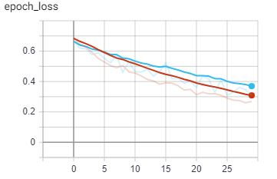

**Figure 7**

From the figure 7, we can conclude that there is still a scope to further decrease the loss without over training our model or without moving towards over fitting because the loss of test data is still decreasing along with the loss of training data.



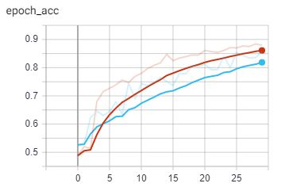

**Figure 8**

The figure 8 shows the test accuracy vs epochs line graph. This model is performing quite well with a accuracy of about 80 percent which can be further improved by increasing the number of epochs

# 5. **RESULTS**

Following are the results obtained after testing the model on 607 test images. Validation accuracy of 81 percent with validation loss of 0.35. Out test data is well balanced with 276 images of ships and 328 images of icebergs out of 604 total images.

|  |  |  |  |  |
| --- | --- | --- | --- | --- |
|  | **Precision** | **Recall** | **f1- score** | **Support** |
| **Ships** | 0.73 | 0.96 | 0.83 | 276 |
| **Icebergs** | 0.95 | 0.70 | 0.80 | 328 |

# 6. **CONCLUSION**

This paper represents the use of CNNs for ship-iceberg discrimination in low-resolution SAR images. One of the major challenges here was the size of the training data. CNNs generally require large datasets to train. We have preprocessed the images with median filtering that removed the speckle noise and increased the accuracy of our model. Unavailability of GPUs couldn’t let us explore various combinations of hyper parameters tuning. This work can be further improved by using other optimizing methods to tune up the hyper parameters.

# 7. ACKNOWLEDGEMENTS

First and foremost, we would like to express our deepest gratitude to our guide Prof. Dr. G. Singh as he was the one who gave us an opportunity to study in this innovative and emerging field. It was through his and academic guidance that we were able to explore our knowledge to the vast domains of remote sensing and were able to contribute a little for the same. He was supportive, enthusiastic, and positive and showed friendly attitude throughout our study.

We would also like to thank all the professors of IIT Bombay for providing us the insights of remote sensing through their vast knowledge in the field.

# 8.. REFERENCES

(2018). Retrieved from Kaggle.com: <https://www.kaggle.com/c/statoil-iceberg-classifier-challenge/data>

(2020, may 20). Retrieved from Tensorflow.org: <https://www.tensorflow.org/tensorboard/get_started>

*Getting started* (n.d.). Retrieved from Keras.io: <https://keras.io/getting_started/>